

press release no. 1

ECOMONDO 2025: INTERNATIONAL RESEARCH AND INNOVATION HUB
FOR THE ECOLOGICAL TRANSITION AND CIRCULAR ECONOMY

- At Rimini Expo Centre from 4th to 7th November, organized by Italian Exhibition Group

- A bigger and even more international edition: seven exhibition sectors and six districts for an integrated vision of the ecological transition

- SAL.VE, the biennial Ecological Vehicle Expo, in partnership with ANFIA, is back

- On the opening day, the States General of the Green Economy

Rimini, October 28, 2025– Ecomondo, Italian Exhibition Group’s (IEG) international event and reference point in Europe and the Mediterranean area for the green, blue and circular economies, will be back at Rimini Expo Centre from 4th to 7th November.
Now at its 28th edition, the largest and most international ever, Ecomondo 2025 confirms its function as a research and innovation hub, capable of combining economic growth, environmental protection and social inclusion, strengthening its role as a meeting place between institutions, enterprises and the scientific world, with the aim of addressing the main challenges of the ecological transition: from advanced recycling to eco-design and environmental monitoring, supported by the most modern digital and satellite technologies.

2025 EDITION HIGHLIGHTS
- 166,000 m² and 30 halls: the entire Expo Centre dedicated to ecological transition.
- Over 1,700 exhibiting brands, 20% from abroad.
- More than 350 hosted buyers from 66 countries expected to attend.
- Over 30 international delegations from 30 countries and about 90 international associations thanks to the support of the Italian Trade Agency and the Ministry of Foreign Affairs and International Cooperation (MAECI).
- More than 200 conference events, 70 of which organized by Ecomondo’s Technical Scientific Committee.
- Insights into WEEE, critical raw materials, textiles, sustainable finance, water resource management and the blue economy, AI, digital twins, bioenergy, circular economy and predictive resource management.
- Fifth edition of the Africa Green Growth Forum to highlight initiatives for access to clean and sustainable energy in Africa, promoted as part of the Mattei Plan and the “Mission 300” programme.
- Extended Innovation District: 40 innovative Start-Ups & SMEs, of which 20 from Morocco and Tunisia selected as part of the “Luca Attanasio” Lab Innovate for Africa project, promoted by the Italian Trade Agency in collaboration with the Ministry of Foreign Affairs and International Cooperation; focus on Green Jobs & Skills, STEM and a new edition of the Lorenzo Cagnoni Award for Green Innovation.
- The return of SAL.VE, the Ecological Vehicle Expo, in partnership with ANFIA.
- New for Ecomondo 2025: themed tours on plastic, water, soil and innovation, available in Italian and English, with over 500 free places per day.
- “WEEE-START: Switch on the change” campaign in collaboration with the Herambiente Group (with the Scart project), the WEEE Coordination Centre (WEEE CC) and the European Week for Waste Reduction (EWWR).
- New direct flight connections to Rimini from Munich and Rome to make international participation easier.
- Ecomondo on the road: three international stop-offs at Cairo, Belgrade and Warsaw to promote contents and collaboration opportunities, consolidating the exhibition’s global reach.

THEMED AREAS
Ecomondo 2025 will be organized into seven macro areas: Waste as Resource, Water Cycle & Blue Economy, Sites & Soil Restoration, Bioenergy & Agriculture, Earth Observation & Environmental Monitoring, Circular and Regenerative Bio-Economy, SAL.VE.

Vertical districts will also be featured; Blue Economy, Circular Healthy City, Paper District, Textile District, Trenchless District and Innovation District.

THE STATES GENERAL OF THE GREEN ECONOMY
A focal point of Ecomondo’s debate is the States General of the Green Economy, organized by the Sustainable Development Foundation in collaboration with the Ministry of the Environment and Energy Security (MASE) and promoted by the National Council of the Green Economy.
The 14th edition, which opens on Tuesday 4th November with the presentation of the Report on the State of the Green Economy 2025, will outline the state of the green economy, not only as an environmental assets and services sector, but on how a decarbonised, circular and positive future economy, being of a sustainable nature, will be able to ensure long-lasting development.
For the first time, the plenary session on 5th November will take place entirely in English, a choice that aims to further broaden the international scope of the event.

INSTITUTIONAL PARTNERS
Ecomondo 2025 is organized by Italian Exhibition Group with the collaboration of: the European Commission; Ministry of the Environment and Energy Security; Ministry of Enterprise and Made in Italy; Agenzia ICE - Italian Trade & Investment Agency; Emilia-Romagna Region; Rimini Municipal Council; ANCI (National Association of Italian Municipalities); ANFIA (National Automotive Industry Association); ART-ER; CIB (Italian Biogas Consortium); CIC (Italian Composter Consortium); CONAI (National Packaging Consortium); ENEA; Assoambiente; Sustainable Development Foundation; ISPRA (Environmental Protection and Research Institute); Legambiente; UNICIRCULAR (Assoambiente section); UNACEA (National Union of Construction Equipment & Attachments Companies); UTILITALIA; CIHEAM (International Centre For Advanced Mediterranean Agronomic Studies); CBE JU (Circular Bio-based Europe Joint Undertaking); EBA (European Biogas Association); European Environment Agency; ISWA (International Solid Waste Association); WBA (World Biogas Association); Water Europe.

ABOUT ECOMONDO 2025
Event: International trade show; Organization: Italian Exhibition Group S.p.A.; Frequency: annual; Edition: 28th; Dates: 4-7 November 2025; mail: ecomondo@iegexpo.it; Website: www.ecomondo.com; Facebook: www.facebook.com/EcomondoRimini; LinkedIn: https://www.linkedin.com/company/ecomondo-the-green-technologies-expo/

PRESS CONTACT IEG/ECOMONDO 2025
head of media relation & corporate communication: Elisabetta Vitali; press office manager: Pierfrancesco Bellini; international press office coordinator: Silvia Giorgi; media@iegexpo.it

MEDIA AGENCY IEG/ECOMONDO: Smartitaly Communications
Edoardo Chiesa, +39 333 8744340 - e.chiesa@smartitaly.it; Paola Gervasio, +39 346 6064272 - p.gervasio@smartitaly.it; Francesca Pericolo, +39 327 9861860 - f.pericolo@smartitaly.it; Foreign Press - Andrea Indiano, +39 349 3232557 – a.indiano@smartitaly.it

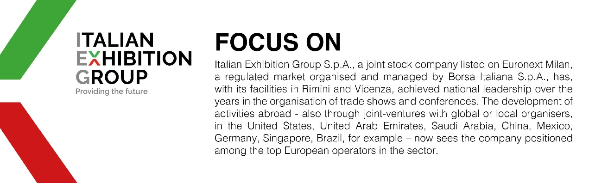

This press release contains forecast elements and estimates that reflect the management’s current opinions (“forward-looking statements”), particularly regarding future management performance, realization of investments, cash flow trends and the evolution of the financial structure. For their very nature, forward-looking statements have a component of risk and uncertainty, as they depend on the occurrence of future events. The effective results may differ (even significantly) from those announced, due to numerous factors, including, only by way of example: food service market and tourist flow trends in Italy, gold and jewellery market trends, green economy market trends; the evolution of raw material prices; general macroeconomic conditions; geopolitical factors and evolutions in the legislative framework. Moreover, the information contained in this release does not claim to be complete, and has not been verified by independent third parties. Forecasts, estimates and objectives contained herein are based on the information available to the Company as at the date of this release.

