

press release no. 3

ECOMONDO 2025: THE GLOBAL THINK TANK FOR ECOLOGICAL TRANSITION

- From 4th to 7th November at Rimini Expo Centre, the 28th edition of the Italian Exhibition Group (IEG) event on the green, blue and circular economies.

- Over 350 hosted international buyers from 66 countries are expected to attend, with Eastern Europe, the Balkans, Asia and Africa increasingly represented, and more than 30 delegations thanks to collaboration with the Italian Trade Agency and the Ministry of Foreign Affairs and International Cooperation (MAECI).

Rimini, 28 october 2025 – Ecomondo continues to extend its international reach. Now at its 28th edition, the event organized by Italian Exhibition Group (IEG) from 4th to 7th November 2025 at Rimini Expo Centre, takes a further step forward by consolidating its global dimension and asserting its role as an important hub for professionals, companies and institutions involved in green, blue and circular economy sectors.

Over 350 international hosted buyers from 66 countries are expected to attend Ecomondo 2025, representing all continents. Top markets include Egypt, Algeria, Spain, Bulgaria, Iraq, Tunisia, Senegal, Canada, Turkey, Serbia, Bosnia and Herzegovina and Jordan, confirming the event's ability to attract high-profile interlocutors from key ecological transition areas. 31% of buyers will arrive from Eastern Europe, the Balkans and Central Asia, 15% from the Middle East and Asia, a further 15% from North Africa, while 13% will come from both Central and Sub-Saharan Africa and Western Europe. Added to this will be Latin America (6%), North America and Australia (5%) and the Far East (2%). To complete the picture, around 90 international associations will be involved and over 30 official delegations will be arriving from 30 countries.

A GLOBAL NETWORK
Thanks to synergy with the Italian Trade Agency and the Ministry of Foreign Affairs and International Cooperation (MAECI), Ecomondo is an unmissable meeting place for international ecological transition stakeholders. Delegations will, in fact, cover almost the entire world map: from Europe to Asia, Latin America and Africa. Particular attention will be paid to the most dynamic markets, consolidating Ecomondo's role as a privileged business hub for the encounter between green technology supply and demand. The qualified buyer presence testifies to the event’s increasing attractiveness and its ability to connect key players in the environmental supply chains on a global scale.

NOT-TO-BE-MISSED INTERNATIONAL CONFERENCES
The conference programme will act as an authentic “international think tank”, with more than 200 conferences and workshops involving the participation of over 800 experts. Debates will touch on crucial and transversal topics such as green financing, digitalisation, climate mitigation and environmental regeneration. Eco-design, waste prevention practices and environmental communication will also be discussed, offering a comprehensive and up-to-date agenda for all those who want to understand and play a leading role in the ecological transition.
Among the most relevant international events organized by Ecomondo’s Technical Scientific Committee, on 4th November, the “Technological solutions for resources recovery from end-of-life products and materials in the Mediterranean landscape” conference will examine new technologies that could increase resource circularity and environmental benefits in various economic sectors. The opening day will also feature a panel discussion entitled “European and Mediterranean nature-based, digital and cyber-physical initiatives projects to innovate water management”, focused on initiatives that integrate nature-based, digital and/or cyber-physical solutions to improve water resource management. Another appointment worth mentioning is “BlueMissionMed: Strengthening the EU Mission Ocean and Waters in the Mediterranean”, organized by Ecomondo’s Technical Scientific Committee, the BlueMissionMed CSA Consortium, and the European Commission. The event will mark the official launch of the EU mission’s annual Mediterranean Lighthouse initiative entitled “Restoring our Ocean and our Waters by 2030”, with particular attention to actions undertaken in the Mediterranean’s current political context. Conferences and in-depth workshops to this regard will be held during the four days of the show.

Developments for the bioeconomy and Earth Observation and Monitoring will be addressed on Wednesday 5th November at the conferences “What bioeconomy for the next generation? Education, innovation and entrepreneurship opportunities across the Mediterranean and Africa” ​​and “From sky to ground: Earth observation for sustainable critical raw materials management”, promoted by Ecomondo’s Technical Scientific Committee and, respectively, the Italian Cluster of Circular Bioeconomy and Turin Polytechnic with CINECA. The same day’s agenda includes the event “Waste Shipment Regulation and its impact on the global market for post consumer textiles”, organized by Ecomondo and UNIRAU, with a panel talk on regulation implementation, in particular with regards to promoting circularity in the global textile market and guaranteeing transparent and compliant export practices.

November 6th will see the “REUSE, REPAIR and ECO-DESIGN. The 'magic' circles of Circular Economy” event, organized by Ecomondo’s Scientific Technical Committee. This conference, divided into two sessions, intends to highlight the most “noble” approaches to the circular economy: reuse, durability, reparability and eco-design, with witness accounts and case studies to show their feasibility within the manufacturing industry.

THE STATES GENERAL OF THE GREEN ECONOMY
Included in the schedule once again is the States General of the Green Economy, organized by the Sustainable Development Foundation in collaboration with the Ministry of the Environment and Energy Security (MASE) and promoted by the National Council of the Green Economy, which comprises 66 business organizations. The international Plenary Session, which will take place on the morning of November 5th, will analyse the prospects, strategies and policies of the green economy within the global debate.

THE AFRICA GREEN GROWTH FORUM
A special place will be reserved for the African continent with the fifth edition of the Africa Green Growth Forum, organized by Ecomondo with the participation of the Mission Structure for the implementation of the Mattei Plan of the Presidency of the Council of Ministers, the Ministry of the Environment and Energy Security, the Ministry of Foreign Affairs and International Cooperation, Confindustria Assafrica & Mediterraneo and RES4Africa.
This new edition of the Forum will highlight the initiatives for access to clean and sustainable energy in Africa promoted under the Mattei Plan and the “Mission 300” Programme, exploring the strategic role of coordinated public and private investments in pursuing growth and climate resilience objectives on the continent.

Conferences on international cooperation scheduled to take place at Ecomondo 2025 will explore global synergies, strengthened by the editions of Ecomondo Mexico and Ecomondo China and by the roadshows already held in Serbia, Poland and Egypt to promote shared sustainable practices. Visitor attendance from abroad will be facilitated by LuxWing charter flights which will fly directly to Rimini from Munich and Rome Fiumicino, two strategic airport hubs.
With a programme of themed tours dedicated to water, plastic and other supply chains, Ecomondo 2025 is an event not to be missed for insiders who want to drive change and find business partners for the ecological transition at an international level.

INSTITUTIONAL PARTNERS
Ecomondo 2025 is organized by Italian Exhibition Group with the collaboration of: the European Commission; Ministry of the Environment and Energy Security; Ministry of Enterprise and Made in Italy; Agenzia ICE - Italian Trade & Investment Agency; Emilia-Romagna Region; Rimini Municipal Council; ANCI (National Association of Italian Municipalities); ANFIA (National Automotive Industry Association); ART-ER; CIB (Italian Biogas Consortium); CIC (Italian Composter Consortium); CONAI (National Packaging Consortium); ENEA; Assoambiente; Sustainable Development Foundation; ISPRA (Environmental Protection and Research Institute); Legambiente; UNICIRCULAR (Assoambiente section); UNACEA (National Union of Construction Equipment & Attachments Companies); UTILITALIA; CIHEAM (International Centre For Advanced Mediterranean Agronomic Studies); CBE JU (Circular Bio-based Europe Joint Undertaking); EBA (European Biogas Association); European Environment Agency; ISWA (International Solid Waste Association); WBA (World Biogas Association); Water Europe.

ABOUT ECOMONDO 2025
Event: International trade show; Organization: Italian Exhibition Group S.p.A.; Frequency: annual; Edition: 28th; Dates: 4-7 November 2025; mail: ecomondo@iegexpo.it; Website: www.ecomondo.com; Facebook: www.facebook.com/EcomondoRimini; LinkedIn: https://www.linkedin.com/company/ecomondo-the-green-technologies-expo/

PRESS CONTACT IEG/ECOMONDO 2025
head of media relation & corporate communication: Elisabetta Vitali; press office manager: Pierfrancesco Bellini; international press office coordinator: Silvia Giorgi; media@iegexpo.it

MEDIA AGENCY IEG/ECOMONDO: Smartitaly Communications
Edoardo Chiesa, +39 333 8744340 - e.chiesa@smartitaly.it; Paola Gervasio, +39 346 6064272 - p.gervasio@smartitaly.it; Francesca Pericolo, +39 327 9861860 - f.pericolo@smartitaly.it; Foreign Press - Andrea Indiano, +39 349 3232557 – a.indiano@smartitaly.it

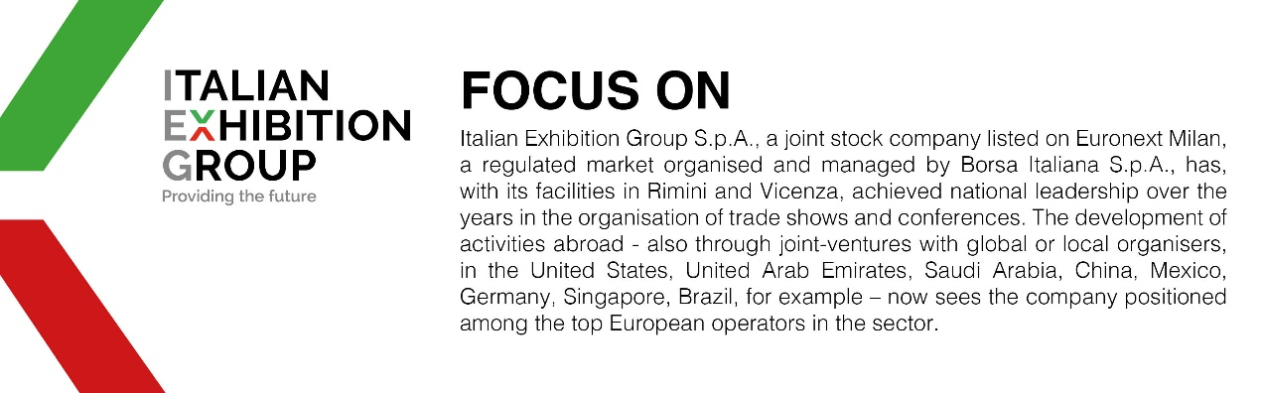

This press release contains forecast elements and estimates that reflect the management’s current opinions (“forward-looking statements”), particularly regarding future management performance, realization of investments, cash flow trends and the evolution of the financial structure. For their very nature, forward-looking statements have a component of risk and uncertainty, as they depend on the occurrence of future events. The effective results may differ (even significantly) from those announced, due to numerous factors, including, only by way of example: food service market and tourist flow trends in Italy, gold and jewellery market trends, green economy market trends; the evolution of raw material prices; general macroeconomic conditions; geopolitical factors and evolutions in the legislative framework. Moreover, the information contained in this release does not claim to be complete, and has not been verified by independent third parties. Forecasts, estimates and objectives contained herein are based on the information available to the Company as at the date of this release.

