

press release no. 4

ECOMONDO 2025: AFRICA’S SUSTAINABLE DEVELOPMENT THE FOCUS OF AFRICA GREEN GROWTH. THE MATTEI PLAN GUIDES EURO-AFRICAN COOPERATION

- The fifth edition of the Forum scheduled for 6th November at Italian Exhibition Group’s (IEG) Rimini Expo Centre

- Participation of the Mission Structure for the implementation of the Mattei Plan of the Presidency of the Council of Ministers, the Ministry of the Environment and Energy Security, the Ministry of Foreign Affairs and International Cooperation, Confindustria Assafrica & Mediterraneo and RES4Africa

- The meeting will see institutions and companies discussing common strategies for sustainable development in Africa within the framework of the Mattei Plan and the “Mission 300” Programme.

Rimini, 28 october 2025 – Africa will once again play a leading role at Ecomondo 2025, Italian Exhibition Group’s (IEG) international event on the green, blue and circular economies to be held at Rimini Expo Centre from 4th to 7th November.

Scheduled for Thursday 6th November at 2 pm, the fifth edition of the Africa Green Growth Forum, organized by Ecomondo with the participation of the Mission Structure for the implementation of the Mattei Plan of the Presidency of the Council of Ministers, the Ministry of the Environment and Energy Security, the Ministry of Foreign Affairs and International Cooperation, Confindustria Assafrica & Mediterraneo and RES4Africa.

A FORUM FOR AFRICA
The most important event dedicated to Africa in Ecomondo’s conference programme will be the Africa Green Growth Forum “The Mattei Plan: dialogue between institutions and the private sector for Africa’s sustainable development”.
The fifth edition will highlight initiatives for access to clean and sustainable energy in Africa promoted as part of the Mattei Plan and the “Mission 300” Programme, a multilateral programme led by the World Bank and the African Development Bank that aims to provide clean and reliable electricity to 300 million people in sub-Saharan Africa by 2030. The Forum will explore how coordinated public and private investments can trigger new opportunities for the sustainable development of the African continent, improve life conditions, reduce poverty, and promote inclusive economic growth.

The conference entitled “Strategic EU R&I Projects for the Green Transition in the Mediterranean and Africa”, organized by Ecomondo’s Technical Scientific Committee and APRE, will also be of importance. Scheduled for Friday 7th November at 10.30 am, the event aims to demonstrate how research and innovation can act as a bridge between Europe, Africa and the Mediterranean and how these efforts contribute to the implementation of the Mattei Plan.

LOCAL START-UPS AND COLLABORATION PROJECTS
Ecomondo 2025’S Innovation District will feature a group of Moroccan and Tunisian startups, active in the green and circular economy sectors, selected as part of the “Luca Attanasio” ICE Lab Innovate for Africa project.

Africa and the Mediterranean are at the centre of Ecomondo's international growth strategies to favour development opportunities for Italian companies in the water, energy, agri-food and circular bioeconomy sectors. Since 2017, the IEG event has promoted initiatives on climate, decontamination and restoration of ecosystems in the Mediterranean and North Africa, in collaboration with the European Commission, the BLUEMED and WestMED initiatives, and the Union for the Mediterranean (UfM).

Following Mattei Plan developments, Ecomondo 2025 will consolidate dialogue between the stakeholders involved, opening new paths for sustainable development in the African continent.

INSTITUTIONAL PARTNERS
Ecomondo 2025 is organized by Italian Exhibition Group with the collaboration of: the European Commission; Ministry of the Environment and Energy Security; Ministry of Enterprise and Made in Italy; Agenzia ICE - Italian Trade & Investment Agency; Emilia-Romagna Region; Rimini Municipal Council; ANCI (National Association of Italian Municipalities); ANFIA (National Automotive Industry Association); ART-ER; CIB (Italian Biogas Consortium); CIC (Italian Composter Consortium); CONAI (National Packaging Consortium); ENEA; Assoambiente; Sustainable Development Foundation; ISPRA (Environmental Protection and Research Institute); Legambiente; UNICIRCULAR (Assoambiente section); UNACEA (National Union of Construction Equipment & Attachments Companies); UTILITALIA; CIHEAM (International Centre For Advanced Mediterranean Agronomic Studies); CBE JU (Circular Bio-based Europe Joint Undertaking); EBA (European Biogas Association); European Environment Agency; ISWA (International Solid Waste Association); WBA (World Biogas Association); Water Europe.

ABOUT ECOMONDO 2025
Event: International trade show; Organization: Italian Exhibition Group S.p.A.; Frequency: annual; Edition: 28th; Dates: 4-7 November 2025; mail: ecomondo@iegexpo.it; Website: www.ecomondo.com; Facebook: www.facebook.com/EcomondoRimini; LinkedIn: https://www.linkedin.com/company/ecomondo-the-green-technologies-expo/

PRESS CONTACT IEG/ECOMONDO 2025
head of media relation & corporate communication: Elisabetta Vitali; press office manager: Pierfrancesco Bellini; international press office coordinator: Silvia Giorgi; media@iegexpo.it

MEDIA AGENCY IEG/ECOMONDO: Smartitaly Communications
Edoardo Chiesa, +39 333 8744340 - e.chiesa@smartitaly.it; Paola Gervasio, +39 346 6064272 - p.gervasio@smartitaly.it; Francesca Pericolo, +39 327 9861860 - f.pericolo@smartitaly.it; Foreign Press - Andrea Indiano, +39 349 3232557 – a.indiano@smartitaly.it

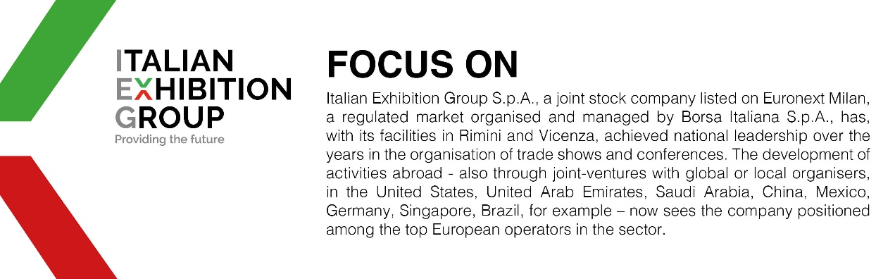

This press release contains forecast elements and estimates that reflect the management’s current opinions (“forward-looking statements”), particularly regarding future management performance, realization of investments, cash flow trends and the evolution of the financial structure. For their very nature, forward-looking statements have a component of risk and uncertainty, as they depend on the occurrence of future events. The effective results may differ (even significantly) from those announced, due to numerous factors, including, only by way of example: food service market and tourist flow trends in Italy, gold and jewellery market trends, green economy market trends; the evolution of raw material prices; general macroeconomic conditions; geopolitical factors and evolutions in the legislative framework. Moreover, the information contained in this release does not claim to be complete, and has not been verified by independent third parties. Forecasts, estimates and objectives contained herein are based on the information available to the Company as at the date of this release.

