

press release no. 5
ECOMONDO 2025: GREEN AND CIRCULAR ECONOMY DATA
- Italy, leader in the green economy: in 2023, the packaging waste recycling rate reached 75.3%, significantly exceeding the EU average and the European objectives for 2030.

- Over 236,000 tonnes of WEEE collected in Italy in the first eight months of 2025 with 65% made up of large household appliances. Small household appliances sent for recycling are on the increase (+5%).

- According to LinkedIn, in 2024, 7.7% of all job offers posted on the platform were for “green” roles or positions with specific sustainability-related skills.

Rimini, 28 october 2025 - The 7th National Report on the circular economy, published last May, the result of collaboration between the Circular Economy Network (CEN) and ENEA, outlined a set of encouraging performances for Italy, which maintains an important position at European level despite growing global complexities.
The analysis, which evaluates circularity in various key dimensions (from production and consumption to waste management and the use of secondary raw materials), established the following ranking among the European Union countries: at the top, with the best absolute performance in the EU, was the Netherlands, which scored 70.6 points. This record was particularly driven by excellent results obtained in the production and consumption, waste management and secondary raw material dimensions.
Italy came in second with 65.2 points. A solid result that reflects excellent indicators in the waste management and production and consumption dimensions, establishing the country as a reference point in the circular transition among the continent's large economies. Germany, in third place with 60.6 points, stood out for one of the best scores recorded in the waste management dimension and boasted good performance in terms of ecological sustainability and resilience. Closing the top part of the ranking were France, in fifth place with 58.7 points, and Spain, which took seventh place with 56.9 points.
The most recent data on the circular economy in Italy confirm the country’s clear superiority in terms of efficiency in the use of resources at a European level. Italy has achieved a resource productivity of 4.3 euros of GDP for every kilo of resources consumed. This result is not only significantly higher than the European Union average, which stands at 2.7 euros per kilo, but also exceeds that of Spain (4.1 euros/kg), France (3.5 euros/kg) and Germany (3.4 euros/kg). The excellence of the Italian system is further highlighted in the packaging waste management sector: in 2023, Italy achieved a recycling rate of 75.3%, significantly exceeding the European average of around 67% and, more importantly, it already achieved the EU objectives set for both 2025 (65%) and 2030 (70%).

RECYCLING AND USE OF SECOND MATERIALS: THE FRAMEWORK IN ITALY AND EUROPE
Italy is one of the leading countries in Europe for the effectiveness of its circular economy model, particularly in the industrial recycling and secondary material integration sectors.

A key indicator is the Circular Material Use Rate (CMUR), which measures the share of recycled materials reintroduced into the production system. In 2023, Italy recorded a CMUR of 20.8% (Eurostat data), almost double the European average (equal to 11.8%), which placed the country in second place in the EU-27, surpassed only by the Netherlands (30.6%) and ahead of nations such as France (17.6%), Germany (13.9%) and Spain (8.5%).

Italian excellence is even more evident in Overall Recycling (which includes urban and special waste). Italy boasts the European record with a total recycling rate of 85.6% in 2024, thanks above all to the record performance of key supply chains such as paper and cardboard: 92.3%; steel: 87.8%; glass: 77.4%; aluminium: 70.3%.

CRITICAL RAW MATERIALS AND PLASTIC, CIRCULAR POTENTIAL
In the ecological transition process, critical raw materials, which include elements such as lithium, cobalt, copper, rare earths, graphite and nickel, are highly strategic resources. That is why, through the Critical Eaw Materials Act, the European Union has defined objectives and measures to reduce external dependence in the supply of these materials, promoting extraction and transformation on the continental territory, and increasing their recycling. By 2030 it is expected to extract 10%, refine 40% and recycle 25% of critical materials, limiting dependence on a single supplier country to below 65% for each material.
This process foresees the virtuous use of WEEE (Waste from Electrical and Electronic Equipment), of which Europe is among the world’s largest producers (4.9 million tonnes in 2022), for example, through urban mining technologies, which enable extracting precious metals from electronic equipment, and virtuous material management policies.
Italy is actively engaged in WEEE valorisation. At a national level, according to data collected by the WEEE Coordination Centre, in the first eight months of 2025, over 236,000 tonnes of WEEE generated by households were collected (+2% compared to the same period in 2024), with large household appliances, such as refrigerators, air conditioners, washing machines and dishwashers exceeding 153,000 tonnes (65% of the collection), followed by small household appliances (over 56,000 tons; +5% compared to 2024), screens and monitors (25,000 tons) and light sources (almost 2,000 tons).
As regards plastic, the European Union consumed 62.8 million tonnes (Eurostat 2022 data), generating 42.5 million tonnes of waste, of which approximately 20% was recycled. However, the figure rose for plastic packaging (41%) thanks to consolidated collection systems.
In Italy the value grew further to 48.9%, with 1.12 million tonnes of recycled packaging compared to a production of approximately 2.3 million tonnes.

ADVANCING LAND CONSUMPTION
Despite this high efficiency, a critical issue emerges in land consumption: in the 2012-2022 decade, the average land consumption figure was 68.7 km², only partially compensated by natural area restoration (just over 8 km²), while the loss of ecosystem services resulted in an economic impact of an estimated 7 to 9 billion euros between 2006 and 2023.

THE FUTURE OF GREEN JOBS
A crucial aspect of the circular economy is also green jobs. According to a LinkedIn report, in 2024, 7.7% of job offers published on the platform involved green positions or roles that required skills related to sustainability.
Nevertheless, a significant challenge has emerged: the difficulty in finding profiles with adequate green skills. In fact, it is estimated that by 2030, almost one in five jobs related to sustainability could remain vacant due to a lack of qualified candidates. The average annual growth since 2020 is 2.55% while 2023 saw a leap to 4.63%, highlighting a gap between supply and demand for specialized skills.
According to Unioncamere's Excelsior Information System on medium-term employment forecasts, the reference time horizon is updated to the five-year period 2025-2029. For different forecast scenarios processed for between 2025 and 2029, the Italian labour market could need between 3.3 and 3.7 million employees. Most of the requirements will be determined by the need to replace workers leaving the job market, while the employment stock could grow over the five-year period from a minimum of 237,000 units up to a maximum of 679,000.
The fastest growing green professional jobs in Italy include sustainability specialist (+19.70%), sustainability consultant (+11.40%) and sustainability manager (+9.62%).

INSTITUTIONAL PARTNERS
Ecomondo 2025 is organized by Italian Exhibition Group with the collaboration of: the European Commission; Ministry of the Environment and Energy Security; Ministry of Enterprise and Made in Italy; Agenzia ICE - Italian Trade & Investment Agency; Emilia-Romagna Region; Rimini Municipal Council; ANCI (National Association of Italian Municipalities); ANFIA (National Automotive Industry Association); ART-ER; CIB (Italian Biogas Consortium); CIC (Italian Composter Consortium); CONAI (National Packaging Consortium); ENEA; Assoambiente; Sustainable Development Foundation; ISPRA (Environmental Protection and Research Institute); Legambiente; UNICIRCULAR (Assoambiente section); UNACEA (National Union of Construction Equipment & Attachments Companies); UTILITALIA; CIHEAM (International Centre For Advanced Mediterranean Agronomic Studies); CBE JU (Circular Bio-based Europe Joint Undertaking); EBA (European Biogas Association); European Environment Agency; ISWA (International Solid Waste Association); WBA (World Biogas Association); Water Europe.

ABOUT ECOMONDO 2025
Event: International trade show; Organization: Italian Exhibition Group S.p.A.; Frequency: annual; Edition: 28th; Dates: 4-7 November 2025; mail: ecomondo@iegexpo.it; Website: www.ecomondo.com; Facebook: www.facebook.com/EcomondoRimini; LinkedIn: https://www.linkedin.com/company/ecomondo-the-green-technologies-expo/

PRESS CONTACT IEG/ECOMONDO 2025
head of media relation & corporate communication: Elisabetta Vitali; press office manager: Pierfrancesco Bellini; international press office coordinator: Silvia Giorgi; media@iegexpo.it

MEDIA AGENCY IEG/ECOMONDO: Smartitaly Communications
Edoardo Chiesa, +39 333 8744340 - e.chiesa@smartitaly.it; Paola Gervasio, +39 346 6064272 - p.gervasio@smartitaly.it; Francesca Pericolo, +39 327 9861860 - f.pericolo@smartitaly.it; Foreign Press - Andrea Indiano, +39 349 3232557 – a.indiano@smartitaly.it

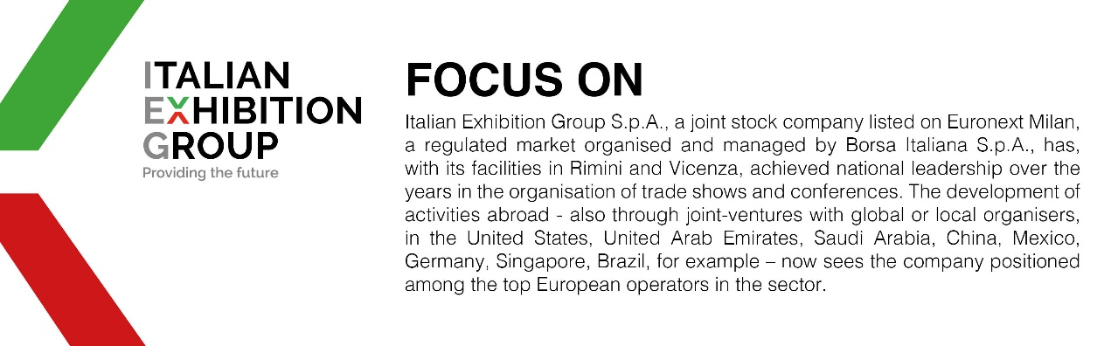

This press release contains forecast elements and estimates that reflect the management’s current opinions (“forward-looking statements”), particularly regarding future management performance, realization of investments, cash flow trends and the evolution of the financial structure. For their very nature, forward-looking statements have a component of risk and uncertainty, as they depend on the occurrence of future events. The effective results may differ (even significantly) from those announced, due to numerous factors, including, only by way of example: food service market and tourist flow trends in Italy, gold and jewellery market trends, green economy market trends; the evolution of raw material prices; general macroeconomic conditions; geopolitical factors and evolutions in the legislative framework. Moreover, the information contained in this release does not claim to be complete, and has not been verified by independent third parties. Forecasts, estimates and objectives contained herein are based on the information available to the Company as at the date of this release.

