

press release no. 6

START-UPS, RESEARCH AND ENTERPRISES:
ECOMONDO 2025, A CIRCULAR INNOVATION LABORATORY

- From 4th to 7th November, at Rimini Expo Centre, Ecomondo will gather together startups, researchers and companies to present solutions that connect digital, environment and sustainable productivity.

- With 40 start-ups and an entire district dedicated to innovation, the Italian Exhibition Group event asserts its role as the main European hub for the green, blue and circular economies.

- Awards and recognitions for the most innovative ecological transition technologies.

Rimini, 28rd October 2025 - Start-ups, research and enterprises will come together at Ecomondo 2025 to present proposals that can translate science into authentic environmental solutions, from the water cycle to the circular bioeconomy. The 28th edition of Italian Exhibition Group’s (IEG) international event on the green, blue and circular economies, scheduled to take place at Rimini Expo Centre from 4th to 7th November, will include the Innovation District with 40 Italian and international start-ups, selected for the high technological content of their proposals. From regenerative bioeconomy to intelligent water management, advanced material recycling and circular agritech, the young companies in attendance will bring solutions able to connect digital, environment and sustainable productivity

A CIRCULAR INNOVATION MAP
The Ecomondo 2025 Call for Start-ups received over 100 applications from Italy and abroad. Project distribution clearly reflects the priorities of the ecological transition and the potential of the macro areas into which the event is divided: 26 applications were received in the Waste as Resource sector, 20 in Circular & Regenerative Bio-Economy, 25 in Environmental Monitoring & Earth Observation, 12 in Water Cycle & Blue Economy, 6 in Bioenergy & Agriculture, and 2 in Site & Soil Restoration. An innovative ecosystem that illustrates the growing attention towards intelligent recycling, environmental monitoring and bioenergy integrated with the agricultural sector.

Of particular interest among the 20 start-ups selected by Ecomondo are Italian projects by innovative companies that offer high-efficiency aquaponic systems for integrated vegetable and fish production with minimal water and energy consumption; a digital platform that measures and enhances soil health; patents that transform complex waste into high-performance polymers, and hybrid operating software that not only controls industrial machines and plants in real time, but also learns over time and ensures continuous optimization. The district will also host 20 start-ups selected as part of the Lab Innova for Africa "Luca Attanasio" project, promoted by the Italian Trade Agency in collaboration with the Ministry of Foreign Affairs and International Cooperation. These Moroccan and Tunisian companies operate in the green economy and circular economy sectors, strengthening the bridge between Europe and the Mediterranean that Ecomondo has been overseeing for years.

TECHNOLOGY AWARDS AND RECOGNITIONS
Together with the Innovation District, Ecomondo will be hosting important awards for ecological transition technologies. The Lorenzo Cagnoni Award, given to the most advanced and promising technologies in Ecomondo’s various exhibition sectors, will be awarded during a gala dinner on 4th November in the presence of policy makers, companies and journalists, with speeches and first-hand accounts from international “green leaders”. The evening will be a special charity dinner whose proceeds will be donated to Go Green, a company that, by recovering rubber, specializes in building running tracks and games for children.

The Award for Sustainable Development, a recognition set up by the Sustainable Development Foundation and Ecomondo, will also be back. Now at its 15th edition, it awards companies, start-ups and local administrations that stand out for eco-innovation, effective environmental and economic results, as well as their diffusion potential. Over the years, 43 First Prizes have been awarded, 379 companies/projects have been recommended and more than 2,300 candidates have participated. The President of the Italian Republic has supported several editions of the Award.

The sectors of the 2025 award are: “Circular Economy” divided into two sections, Enterprise Section in collaboration with the Circular Economy Network and Start-up Section in collaboration with CONAI and with the support of STEP SB - Innovation Hub; “Decarbonization and climate adaptation”, organized in collaboration with Italy for Climate, GSE – Energy Services Manager and ISPRA, with the participation of ENEA; “Nature restoration interventions”, carried out in collaboration with the Green City Network, the Nature Positive Network and the Po River Basin District Authority. The awards ceremony for the 2025 edition will take place in the afternoon of 5th November, from 2.15 to 4.00 pm, in the Innovation District.

YOUNG GENERATION, SCIENCE AND VISION
Ecomondo 2025 will strengthen the link between innovation and training. Events scheduled for 6th November will include a speech on STEM professions and a meeting with astronaut Walter Villadei designed to inspire the new generations and introduce them to technical-scientific careers.

Also within the Innovation District, the special Green Jobs & Skills area will act as a facilitator between job supply and demand for recent university and high school graduates, young professionals, workers who want to move towards sustainability and companies engaged in the ecological transition.

Ecomondo 2025 is therefore confirmed as the place where technology meets vision: an ecosystem of start-ups, awards and meetings that fuels the circular economy and gets young enterprises ready for the challenges of a sustainable future.

INSTITUTIONAL PARTNERS
Ecomondo 2025 is organized by Italian Exhibition Group with the collaboration of: the European Commission; Ministry of the Environment and Energy Security; Ministry of Enterprise and Made in Italy; Agenzia ICE - Italian Trade & Investment Agency; Emilia-Romagna Region; Rimini Municipal Council; ANCI (National Association of Italian Municipalities); ANFIA (National Automotive Industry Association); ART-ER; CIB (Italian Biogas Consortium); CIC (Italian Composter Consortium); CONAI (National Packaging Consortium); ENEA; Assoambiente; Sustainable Development Foundation; ISPRA (Environmental Protection and Research Institute); Legambiente; UNICIRCULAR (Assoambiente section); UNACEA (National Union of Construction Equipment & Attachments Companies); UTILITALIA; CIHEAM (International Centre For Advanced Mediterranean Agronomic Studies); CBE JU (Circular Bio-based Europe Joint Undertaking); EBA (European Biogas Association); European Environment Agency; ISWA (International Solid Waste Association); WBA (World Biogas Association); Water Europe.

ABOUT ECOMONDO 2025
Event: International trade show; Organization: Italian Exhibition Group S.p.A.; Frequency: annual; Edition: 28th; Dates: 4-7 November 2025; mail: ecomondo@iegexpo.it; Website: www.ecomondo.com; Facebook: www.facebook.com/EcomondoRimini; LinkedIn: https://www.linkedin.com/company/ecomondo-the-green-technologies-expo/

PRESS CONTACT IEG/ECOMONDO 2025
head of media relation & corporate communication: Elisabetta Vitali; press office manager: Pierfrancesco Bellini; international press office coordinator: Silvia Giorgi; media@iegexpo.it

MEDIA AGENCY IEG/ECOMONDO: Smartitaly Communications
Edoardo Chiesa, +39 333 8744340 - e.chiesa@smartitaly.it; Paola Gervasio, +39 346 6064272 - p.gervasio@smartitaly.it; Francesca Pericolo, +39 327 9861860 - f.pericolo@smartitaly.it; Foreign Press - Andrea Indiano, +39 349 3232557 – a.indiano@smartitaly.it

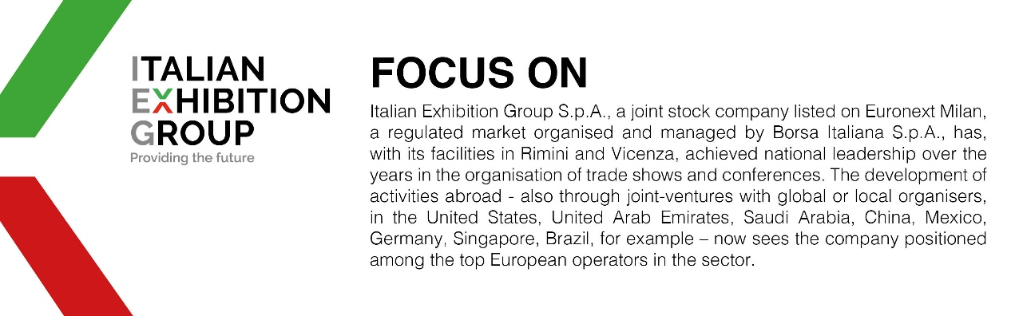

This press release contains forecast elements and estimates that reflect the management’s current opinions (“forward-looking statements”), particularly regarding future management performance, realization of investments, cash flow trends and the evolution of the financial structure. For their very nature, forward-looking statements have a component of risk and uncertainty, as they depend on the occurrence of future events. The effective results may differ (even significantly) from those announced, due to numerous factors, including, only by way of example: food service market and tourist flow trends in Italy, gold and jewellery market trends, green economy market trends; the evolution of raw material prices; general macroeconomic conditions; geopolitical factors and evolutions in the legislative framework. Moreover, the information contained in this release does not claim to be complete, and has not been verified by independent third parties. Forecasts, estimates and objectives contained herein are based on the information available to the Company as at the date of this release.

