

press release no. 7

THE ECOMONDO 2025 LAYOUT

- Seven themed macro-areas and six vertical districts for an integrated vision of the ecological transition

- Distributed over 166,000 square metres and 30 halls

- SAL.VE, the Ecological Vehicle Exhibition in partnership with ANFIA is back

Rimini, 28 october 2025 - For its 28th edition (Rimini Expo Centre, 4-7 November), Ecomondo is offering a layout that reflects the growing importance of the ecological transition and the circular economy.

The Italian Exhibition Group event will occupy a total exhibition area of ​​166,000 square meters across 30 halls, in continuity with the expansion of the 2024 edition and with several new features, such as the return of SAL.VE, the biennial Ecological Vehicle Exhibition, organized in partnership with ANFIA.

The Ecomondo 2025 layout is divided into seven macro thematic areas and six vertical districts. This arrangement will allow visitors to orient themselves easily between the different sections, optimizing the exhibition itinerary and facilitating the encounter between supply and demand in the sustainability and Green Economy sectors.

ECOMONDO 2025: THE EXHIBITION ITINERARY
The West wing halls (A1-A6, C3-C6) as well as some in the East area (B1-B4) will host Waste as Resource, the sector where Ecomondo is leader and one of the event’s most solid. This section enables visitors to explore the most recent innovations in waste collection, management and valorisation processes, understand the importance of recycling as a resource, and learn about circular economy models.

Furthermore, the new WEEE District will also be located in this area with a specific focus on repowering technologies and new recycling plants for electronic waste, photovoltaic panels and wind turbines.

Another new feature of the Ecomondo 2025 layout is the return of the SAL.VE area, the biennial Ecological Vehicle Exhibition: halls A7 and C7 will house the entire production range of equipment for industrial and special vehicles for waste collection and road sweeping.

Halls C1, C2, D1 and part of D2 will be reserved for the Site & Soil Restoration area, a macro-cluster focused on the main technologies for environmental restoration, remediation, and contaminated site management.

East wing halls D2-D4 will provide space for Circular & Regenerative Bio-economy, focusing on processes linked to the regenerative economy and the bioeconomy. Halls B5, part of B6 and D5 will host the Bio-Energy & Agriculture sector, where visitors will not only learn about bio-based circular production processes, but also be updated on the latest technologies for valorising agricultural and non-agricultural wastewater, and for the production of biogas and biomethane.

The Water Cycle & Blu Economy sector has been extended and will be located in halls B6-B8 and D7-D8. Here, issues related to the sustainable management of water resources, purification, aqueducts, the development of the ocean economy and innovative technologies for the blue economy will be further explored.

Hall D6 will host the Earth Observation & Environmental Monitoring area for the latest satellite monitoring technologies which, combined with big data and artificial intelligence models, offer powerful tools for tackling climate change with particular attention to hydrogeological instability, the protection of green areas, soil, water resources and urban health.

THE DISTRICTS
The seven macro-areas will be joined by six vertical districts to complete Ecomondo's exhibition offer.

In this edition of the event, the Trenchless District, dedicated to no-dig technologies for underground infrastructures, which will also host an IATT collective, will be located in the Water Cycle & Blu Economy area, which will also host the Blue Economy District with the dual objective of disseminating good practices and projects related to the circular economy and giving visibility to companies connected to the ocean, sea and coastal worlds.

The Textile District will be an area of ​​exchange that aims to involve all stakeholders in the textile supply chain and draw attention to the importance of a more sustainable model for the sector. The Paper District, on the other hand, will feature sustainable paper design in all its forms, bringing together all the players operating in this production branch with the aim of making the most of the supply chain’s possibilities.

The Circular&Healthy City district will be an exhibition and virtual area to take visitors into the future of built-up environments. Here, visitors will be able to discover how to rethink construction and urban planning, delve into intelligent technologies at the service of the city and improve environmental and collective health by enhancing resources and recycling them more efficiently.

Last but not least, the Innovation District in the South Hall will continue to be the centre of innovation, an area designed as an open innovation path to connect institutions, research centres and companies at the forefront of the ecological transition. It will include the start-up and scale-up areas as well as the Green Jobs & Skills project, which promotes the encounter between young talent and sector companies, thus encouraging the development of new green skills.

INSTITUTIONAL PARTNERS
Ecomondo 2025 is organized by Italian Exhibition Group with the collaboration of: the European Commission; Ministry of the Environment and Energy Security; Ministry of Enterprise and Made in Italy; Agenzia ICE - Italian Trade & Investment Agency; Emilia-Romagna Region; Rimini Municipal Council; ANCI (National Association of Italian Municipalities); ANFIA (National Automotive Industry Association); ART-ER; CIB (Italian Biogas Consortium); CIC (Italian Composter Consortium); CONAI (National Packaging Consortium); ENEA; Assoambiente; Sustainable Development Foundation; ISPRA (Environmental Protection and Research Institute); Legambiente; UNICIRCULAR (Assoambiente section); UNACEA (National Union of Construction Equipment & Attachments Companies); UTILITALIA; CIHEAM (International Centre For Advanced Mediterranean Agronomic Studies); CBE JU (Circular Bio-based Europe Joint Undertaking); EBA (European Biogas Association); European Environment Agency; ISWA (International Solid Waste Association); WBA (World Biogas Association); Water Europe.

ABOUT ECOMONDO 2025
Event: International trade show; Organization: Italian Exhibition Group S.p.A.; Frequency: annual; Edition: 28th; Dates: 4-7 November 2025; mail: ecomondo@iegexpo.it; Website: www.ecomondo.com; Facebook: www.facebook.com/EcomondoRimini; LinkedIn: https://www.linkedin.com/company/ecomondo-the-green-technologies-expo/

PRESS CONTACT IEG/ECOMONDO 2025
head of media relation & corporate communication: Elisabetta Vitali; press office manager: Pierfrancesco Bellini; international press office coordinator: Silvia Giorgi; media@iegexpo.it

MEDIA AGENCY IEG/ECOMONDO: Smartitaly Communications
Edoardo Chiesa, +39 333 8744340 - e.chiesa@smartitaly.it; Paola Gervasio, +39 346 6064272 - p.gervasio@smartitaly.it; Francesca Pericolo, +39 327 9861860 - f.pericolo@smartitaly.it; Foreign Press - Andrea Indiano, +39 349 3232557 – a.indiano@smartitaly.it

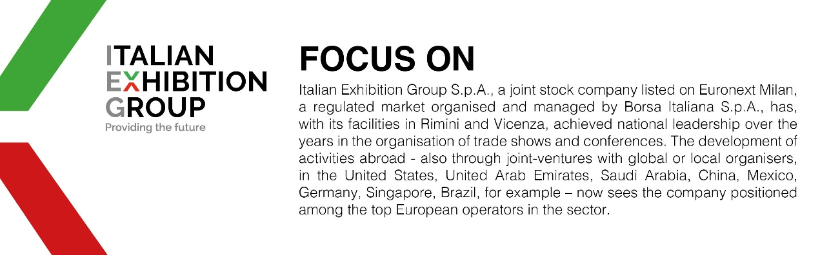

This press release contains forecast elements and estimates that reflect the management’s current opinions (“forward-looking statements”), particularly regarding future management performance, realization of investments, cash flow trends and the evolution of the financial structure. For their very nature, forward-looking statements have a component of risk and uncertainty, as they depend on the occurrence of future events. The effective results may differ (even significantly) from those announced, due to numerous factors, including, only by way of example: food service market and tourist flow trends in Italy, gold and jewellery market trends, green economy market trends; the evolution of raw material prices; general macroeconomic conditions; geopolitical factors and evolutions in the legislative framework. Moreover, the information contained in this release does not claim to be complete, and has not been verified by independent third parties. Forecasts, estimates and objectives contained herein are based on the information available to the Company as at the date of this release.

