

press release no. 9

HOW TO GET TO AND AROUND ECOMONDO 2025
SERVICE GUIDE

Rimini, 28 october 2025 – Italian Exhibition Group offers operators and visitors numerous services, green and sustainable ones included, to easily arrive at Ecomondo, the 28th edition of which is scheduled to take place from 4th to 7th November at Rimini Expo Centre.

Entry to the Expo Centre: access is through the South (via Emilia, 155), East (via Costantino il Grande) and West (via San Martino in Riparotta) entrances.

Opening times: From Tuesday 4th to Thursday 6th November 2025, from 9.30 am to 6.30 pm and Friday 7th November from 9.30 am to 6 pm.

Ticket Office: Admission is subject to prior registration. Tickets purchased online before the show will cost €15 for one day and €30 for two days (until 3/11). During the show, online prices will be €30 for one day and €40 for two days. At the ticket office, prices will be €35 for one day and €45 for two days. For assistance, contact +39 0541 744555 or write to helpdesk.rn@iegexpo.it.

University students can purchase tickets at the discounted price of €5 on presentation of a student identification card or any other proof of university enrolment.

Services for the disabled: Italian Exhibition Group ensures easy access for all visitors. The Expo Centre is totally accessible. The STATION, SOUTH 1-3-4 and West 1-2 car parks have disabled parking facilities.

GETTING TO THE EXPO CENTRE
Car: From the A14 Bologna-Bari-Taranto motorway, exit Rimini North (6 km from the Expo Centre).

Parking: There are 12 electric vehicle charging stations, for a total 24 plug-ins of which 6 in the SOUTH 1 car park and 6 in the WEST 1-2 car parks.

Train: RiminiFiera station, on the Milan-Bari line, is 50 metres from the South entrance and can be reached by regional, Intercity and Frecce train services at discounted prices and with special trains on the Santarcangelo di R. – Cattolica tract. Assistance service for passengers with disabilities and reduced mobility (PRM) is available at Riminifiera station.
The Expo Centre is also connected to Rimini Station by public transport: bus line 9 bis (DIRECT to Rimini Expo-South Entrance) and line 9 (bus stop via Emilia-Expo).

Plane: The Rimini - San Marino “Federico Fellini” International Airport is directly connected to the Expo Centre via a free shuttle service, subject to reservation, active during the days of the event. For the 2025 edition, charter flights are planned from Munich and Rome Fiumicino operated by LuxWing and available every day from 4th to 7th November. Discounted fares are also available with companies in the Lufthansa Group, valid for flights up to one week before and one week after the event.
Shuttle Bus Bologna Airport: Direct connections from and to Bologna Airport from 4th to 7th November (single journey ticket can be purchased online at a cost of €5, or at the desk in the Arrivals Area of ​​Bologna Airport and on board the bus at a cost of €30). Moreover, the connection service between the Guglielmo Marconi airport in Bologna and the city of Rimini is active all year round (stops: Rimini Railway Station, Rimini Via Fada).
There are also bus, shuttle and train connections to the Expo Centre from the following airports: Forlì “Luigi Ridolfi” Airport, Falconara Airport (Ancona), Milan Linate and Milan Malpensa, Venice, Treviso and Bergamo “Orio al Serio”

Metromare: a public transport system on a dedicated route that connects the Rimini and Riccione railway stations in 23 minutes, passing through 15 intermediate stations. Daily trips run approximately every 15 minutes.

Bus: The Expo Centre can be reached on lines 5 (San Mauro Mare Rimini north - Rimini Expo), 10 (Miramare Rimini South - Rimini Expo), 9bis (Rimini Railway Station - Rimini Expo, with no intermediate stops), 9 (Rimini Railway Station - Rimini Expo).

Special buses: Free services connect Rimini Marina Centro, Riccione and Bellaria to the Expo Centre.

Electric micro-mobility: shared electric bicycles and scooters are available from Lime and BIT Mobility with promotional codes for Ecomondo visitor discounts. (LIMEXFIERA and ECOMONDOBIT2025)

Taxi: Service available by calling +39 0541/50020.

Car Hire: Special rates with AVIS Autonoleggio.

Helicopter: The Expo Centre has a helipad. For further information: martina.mazzoli@iegexpo.it

Further information on every way to reach Ecomondo 2025 is available on the following link: https://www.ecomondo.com/it/visitare/come-arrivare

INSTITUTIONAL PARTNERS
Ecomondo 2025 is organized by Italian Exhibition Group with the collaboration of: the European Commission; Ministry of the Environment and Energy Security; Ministry of Enterprise and Made in Italy; Agenzia ICE - Italian Trade & Investment Agency; Emilia-Romagna Region; Rimini Municipal Council; ANCI (National Association of Italian Municipalities); ANFIA (National Automotive Industry Association); ART-ER; CIB (Italian Biogas Consortium); CIC (Italian Composter Consortium); CONAI (National Packaging Consortium); ENEA; Assoambiente; Sustainable Development Foundation; ISPRA (Environmental Protection and Research Institute); Legambiente; UNICIRCULAR (Assoambiente section); UNACEA (National Union of Construction Equipment & Attachments Companies); UTILITALIA; CIHEAM (International Centre For Advanced Mediterranean Agronomic Studies); CBE JU (Circular Bio-based Europe Joint Undertaking); EBA (European Biogas Association); European Environment Agency; ISWA (International Solid Waste Association); WBA (World Biogas Association); Water Europe.

ABOUT ECOMONDO 2025
Event: International trade show; Organization: Italian Exhibition Group S.p.A.; Frequency: annual; Edition: 28th; Dates: 4-7 November 2025; mail: ecomondo@iegexpo.it; Website: www.ecomondo.com; Facebook: www.facebook.com/EcomondoRimini; LinkedIn: https://www.linkedin.com/company/ecomondo-the-green-technologies-expo/

PRESS CONTACT IEG/ECOMONDO 2025
head of media relation & corporate communication: Elisabetta Vitali; press office manager: Pierfrancesco Bellini; international press office coordinator: Silvia Giorgi; media@iegexpo.it

MEDIA AGENCY IEG/ECOMONDO: Smartitaly Communications
Edoardo Chiesa, +39 333 8744340 - e.chiesa@smartitaly.it; Paola Gervasio, +39 346 6064272 - p.gervasio@smartitaly.it; Francesca Pericolo, +39 327 9861860 - f.pericolo@smartitaly.it; Foreign Press - Andrea Indiano, +39 349 3232557 – a.indiano@smartitaly.it

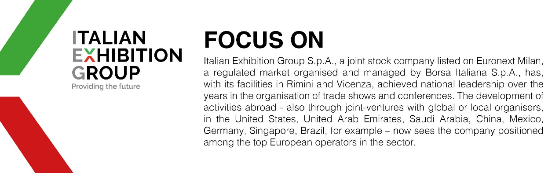

This press release contains forecast elements and estimates that reflect the management’s current opinions (“forward-looking statements”), particularly regarding future management performance, realization of investments, cash flow trends and the evolution of the financial structure. For their very nature, forward-looking statements have a component of risk and uncertainty, as they depend on the occurrence of future events. The effective results may differ (even significantly) from those announced, due to numerous factors, including, only by way of example: food service market and tourist flow trends in Italy, gold and jewellery market trends, green economy market trends; the evolution of raw material prices; general macroeconomic conditions; geopolitical factors and evolutions in the legislative framework. Moreover, the information contained in this release does not claim to be complete, and has not been verified by independent third parties. Forecasts, estimates and objectives contained herein are based on the information available to the Company as at the date of this release.

