

press release
(English translation)

ECOMONDO 2025 ON THE ROAD: THREE INTERNATIONAL STOPS
AHEAD OF THE NOVEMBER EDITION AT RIMINI EXPO CENTRE (ITALY)

- Scheduled for 8th July in Cairo, 9th September in Belgrade and 11th September in Warsaw
- With the roadshow, IEG is extending the reach of its green, blue and circular economy in Europe and the Mediterranean basin event of reference
Rimini (Italy), 1 July 2025 – In view of the coming edition of Ecomondo, scheduled for 4-7 November 2025 at Rimini Expo Centre in Italy, Italian Exhibition Group is promoting three international stops designed to anticipate content, technologies and collaboration opportunities in key sectors of the ecological transition. The tour will involve Egypt, Serbia and Poland, strengthening the dialogue between Italian companies and foreign markets and consolidating Ecomondo as a reference hub for the green, blue and circular economy in the Mediterranean and Europe. The stops will provide an opportunity to engage with high-profile international operators and buyers from the countries involved in the roadshow prior to the next edition of Ecomondo.
THREE STOPS FOR ECOMONDO’S INTERNATIONAL ROADSHOW
The first stop will be on 8th July in Cairo, in collaboration with the Italian Chamber of Commerce for Egypt, the Italian Embassy and the Italian Trade Agency Office. The main topics of the meeting will be the water cycle, bioenergy in agriculture, waste management and energy efficiency. Egypt has defined a National Climate Strategy 2050 and is aiming to produce 42% of renewable energy by 2035. The event will include themed sessions and B2B meetings between Egyptian stakeholders and Italian companies with the participation of public and private entities operating in environmental sectors. In 2024, the Egyptian delegation counted 40 top buyers from industries, utilities, municipalities and ESCOs, with 401 B2B meetings organized both during Ecomondo and at KEY - The Energy Transition Expo.
On September 9th the roadshow will arrive in Belgrade, Serbia, in collaboration with the Serbian Chamber of Commerce and Industry and with support from regional advisor, MZ Consulting. The meeting will focus on Waste Management, Solar Energy and Water, rapidly-growing strategic areas in the Balkans, where investments in sustainability are driven by local incentives and EU pre-accession programs.
September 11th will be the turn of Warsaw with the Green Grill format created with Confindustria Poland. An informal, low-impact networking event has been scheduled, inspired by the values of Ecomondo and KEY, with a focus on biogas, plastic waste management, water treatment and solar energy. Guests will include Italian companies and Polish stakeholders, who will discuss concrete projects and applied technologies. Participation comes within a context in which Poland is investing decisively in order to modernize its environmental infrastructure thanks to European funds and national plans. Confindustria Poland now has 105 member companies, 30,000 represented employees and an aggregate turnover of 4.6 billion euros.

ECOMONDO 2025 TOPICS
The three international stops will preview many of the topics programmed to feature at Ecomondo 2025, distributed along a high-tech exhibition and conference itinerary. The November edition will focus on seven macro-areas: Waste as Resource, Water Cycle & Blue Economy, Sites & Soil Restoration, Bioenergy & Agriculture, Earth Observation and Environmental Monitoring, Circular and Regenerative Bio-Economy as well as the biennial event SAL.VE, the ANFIA members expo of ecology sector vehicles.
Also confirmed are vertical districts such as Blue Economy, dedicated to safeguarding marine ecosystems, Circular Healthy City for circular and healthy cities, the Paper District for sustainable paper design, the Textile District for ethical fashion and the Trenchless District, which will focus on No Dig technologies.

The Innovation District will be the centre of applied research with an extended area for Start-Up & Scale-Up and a focus on Green Jobs & Skills. The Lorenzo Cagnoni Award for Green Innovation will also be back to highlight the most advanced technologies in the various sectors represented.
A conference program, organized by the Technical Scientific Committee, will complete the trade show experience by taking a close look at regulatory developments, ecosystem restoration, new forms of bioenergy and predictive resource management with specific focuses on the Mattei Plan and the role of green technologies in the African context.

INSTITUTIONAL PARTNERS
Ecomondo 2025 is organized by Italian Exhibition Group with the collaboration of: European Commission; Ministry for the Environment and Energy Security; Ministry of Enterprise and Made in Italy; ITA - Italian Trade & Investment Agency; Emilia-Romagna Region; Rimini City Council; ANCI (National Association of Italian Municipalities); ANFIA (National Automobile Industry Supply Chain Association); ART-ER; CIB (Italian Biogas Consortium); CIC (Italian Composters’ Consortium); CONAI (National Packaging Consortium); ENEA; Assoambiente; Sustainable Development Foundation; ISPRA (Higher Institute for Environmental Protection and Research); Legambiente; UNICIRCULAR (Assoambiente section); UNACEA (National Union of Construction Equipment & Attachment Companies); UTILITALIA; CIHEAM (International Centre For Advanced Mediterranean Agronomic Studies) CBE JU (Circular Bio-based Europe Joint Undertaking); EBA (European Biogas Association); European Environment Agency; ISWA (International Solid Waste Association); WBA (World Biogas Association); Water Europe.

ABOUT ECOMONDO 2025
Event: International trade show; Organization: Italian Exhibition Group S.p.A.; Frequency: annual; Edition: 28th; Dates: 4-7 November 2025; mail: ecomondo@iegexpo.it; Website: www.ecomondo.com; Facebook: www.facebook.com/EcomondoRimini; LinkedIn: https://www.linkedin.com/company/ecomondo-the-green-technologies-expo/

PRESS CONTACT IEG/ECOMONDO 2025
head of media relation & corporate communication: Elisabetta Vitali; press office manager: Pierfrancesco Bellini; international press office coordinator: Silvia Giorgi; media@iegexpo.it

MEDIA AGENCY IEG/ECOMONDO: Smartitaly Communications
Edoardo Chiesa, +39 333 8744340 - e.chiesa@smartitaly.it; Paola Gervasio, +39 346 6064272 - p.gervasio@smartitaly.it; Francesca Pericolo, +39 327 9861860 - f.pericolo@smartitaly.it; Stampa estera - Andrea Indiano, +39 349 3232557 – a.indiano@smartitaly.it

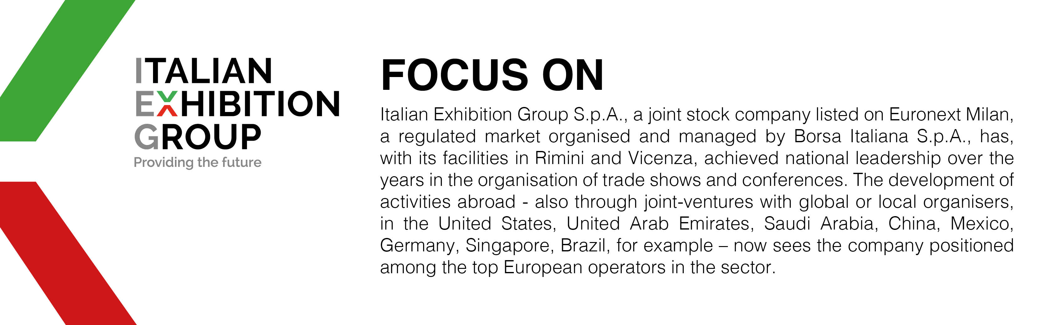

This press release contains forecast elements and estimates that reflect the management’s current opinions (“forward-looking statements”), particularly regarding future management performance, realization of investments, cash flow trends and the evolution of the financial structure. For their very nature, forward-looking statements have a component of risk and uncertainty, as they depend on the occurrence of future events. The effective results may differ (even significantly) from those announced, due to numerous factors, including, only by way of example: food service market and tourist flow trends in Italy, gold and jewellery market trends, green economy market trends; the evolution of raw material prices; general macroeconomic conditions; geopolitical factors and evolutions in the legislative framework. Moreover, the information contained in this release does not claim to be complete, and has not been verified by independent third parties. Forecasts, estimates and objectives contained herein are based on the information available to the Company as at the date of this release.

