

Final press release

WONDERFUL ECOMONDO!
AT THE 2025 EDITION, +7% IN TOTAL ATTENDANCE.
FOREIGN ATTENDANCE up by 10%.
THE ECOLOGICAL TRANSITION HUB IS BECOMING INCREASINGLY GLOBAL

- Today marks the end of the 28th edition of Italian Exhibition Group’s green, blue and circular economy event: the most international ever
- Minister Pichetto Fratin’s visit: “Ecomondo symbol of innovation and sustainability”
- More than 800 hosted buyers and delegations from 65 countries
- Over 1,700 exhibitors, of which 18% from abroad.
Rimini, 7th November 2025 – In an increasingly volatile global context, sustainability is the compass that guides governments, businesses and the scientific community. Ecomondo 2025, Europe and the Mediterranean basin’s leading international event for the green, blue and circular economies, organized by Italian Exhibition Group (IEG), came to a close today at Rimini Expo Centre, reaffirming its status as a global hub for ecological transition. A role reflected in the concrete results of an expanding 28th edition.

Total attendance grew by +7%, with +10% from abroad. Over 1,700 exhibiting brands, of which 18% from abroad, covering 166,000 square metres of exhibition space. More than 600 journalists accredited (15% from abroad), brought Rimini Expo Centre to the attention of the global community.

Underlining Ecomondo's central role on the international scene as a guide along the path towards a sustainable future that, starting in Italy, Europe is continuing to pursue with determination, was the Minister for the Environment and Energy Security, Gilberto Pichetto Fratin, who toured the exhibition halls on Thursday 6th November. “We can count ourselves among the leading countries in the world in terms of recycling capacity,” the minister explained. “There is a lot of talk about rare earths and critical raw materials, but the largest deposit we have is our waste... And the ability to recycle is fully demonstrated at this show, a symbol of innovation and sustainability.”

ECOMONDO 2025, THE MOST INTERNATIONAL EDITION EVER
Ecomondo 2025 confirmed its status as a privileged venue for exchange between companies, researchers and professionals from around the world, also thanks to its collaboration with the Italian Trade Agency (ITA) and the Ministry of Foreign Affairs and International Cooperation (MAECI). A global crossroads with over 800 hosted buyers and international delegations from 65 countries. The most represented markets included Spain, Turkey, Poland, Romania, Serbia, Croatia, Bulgaria, Tunisia, Morocco and Egypt. To complete the picture, around 90 international associations were also involved. During the event, this network generated 3,800 business matches, promoting cooperation and the dissemination of best ecological transition practices.

GREEN TRANSITION, A TRANSVERSAL OVERVIEW OF THE GLOBAL CONTEXT
Over 200 events took place over the four days, around 70 of which organized by Ecomondo's Technical and Scientific Committee, chaired by Professor Fabio Fava, in a programme packed with initiatives, offering an up-to-date interpretation of the green transition across a range of sectors. Key topics included: WEEE and critical raw materials, the circular textile industry, sustainable finance in support of the ecological transition, water management and the blue economy, bioenergy, the circular economy, AI applied to resource enhancement and data monitoring, Earth observation and the role of communication in overcoming false ecological transition dilemmas.
Considerable attention was paid to international cooperation and the green transition in the Mediterranean, as well as initiatives for accessing clean and sustainable energy in Africa, as part of the Mattei Plan and the “Mission 300” programme, with the fifth edition of the Africa Green Growth Forum.
The 14th edition of the States General of the Green Economy once again opened Ecomondo with a presentation of the Report on the State of the Green Economy 2025, placing the state and prospects of the European ecological transition in the new global context at the centre of the debate. The plenary session on the second day, held entirely in English for the first time, further broadened the international scope of the event.

The return of Sal.Ve, the biennial Exhibition of Ecological Vehicles, in partnership with ANFIA, showcased the entire product range of equipment for industrial and special vehicles for collecting solid and liquid waste, street sweeping and sewage disposal.

THE INNOVATION LABORATORY
At Ecomondo 2025, innovation bridged the gap between science and market: the Innovation District provided space and visibility to 40 Italian and international high-tech start-ups, including 20 from Morocco and Tunisia selected as part of the “Luca Attanasio” Lab Innovates for Africa project, promoted by the Italian Trade Agency in collaboration with the Ministry of Foreign Affairs and International Cooperation. To accompany the exhibition, Ecomondo presented the “Lorenzo Cagnoni” Award for Green Innovation to seven exhibiting companies, one from each of the event’s sectors, for the most advanced and promising technologies.

ECOMONDO WILL BE BACK AT ITALIAN EXHIBITION GROUP’S RIMINI EXPO CENTRE FROM 3RD TO 6TH NOVEMBER 2026.

INSTITUTIONAL PARTNERS
Ecomondo 2025 is organized by Italian Exhibition Group with the collaboration of: the European Commission; Ministry of the Environment and Energy Security; Ministry of Enterprise and Made in Italy; Agenzia ICE - Italian Trade & Investment Agency; Emilia-Romagna Region; Rimini Municipal Council; ANCI (National Association of Italian Municipalities); ANFIA (National Automotive Industry Association); ART-ER; CIB (Italian Biogas Consortium); CIC (Italian Composter Consortium); CONAI (National Packaging Consortium); ENEA; Assoambiente; Sustainable Development Foundation; ISPRA (Environmental Protection and Research Institute); Legambiente; UNICIRCULAR (Assoambiente section); UNACEA (National Union of Construction Equipment & Attachments Companies); UTILITALIA; CIHEAM (International Centre For Advanced Mediterranean Agronomic Studies); CBE JU (Circular Bio-based Europe Joint Undertaking); EBA (European Biogas Association); European Environment Agency; ISWA (International Solid Waste Association); WBA (World Biogas Association); Water Europe.

ABOUT ECOMONDO 2025
Event: International trade show; Organization: Italian Exhibition Group S.p.A.; Frequency: annual; Edition: 28th ; Dates: 4-7 November 2025; mail: ecomondo@iegexpo.it; Website: www.ecomondo.com; Facebook: www.facebook.com/EcomondoRimini; LinkedIn: https://www.linkedin.com/company/ecomondo-the-green-technologies-expo/
PRESS CONTACT IEG/ECOMONDO 2025
head of media relation & corporate communication: Elisabetta Vitali; press office manager: Pierfrancesco Bellini; international press office coordinator: Silvia Giorgi; media@iegexpo.it
MEDIA AGENCY IEG/ECOMONDO: Smartitaly Communications
Edoardo Chiesa, +39 333 8744340 - e.chiesa@smartitaly.it; Paola Gervasio, +39 346 6064272 - p.gervasio@smartitaly.it; Francesca Pericolo, +39 327 9861860 - f.pericolo@smartitaly.it; Stampa estera - Andrea Indiano, +39 349 3232557 – a.indiano@smartitaly.it

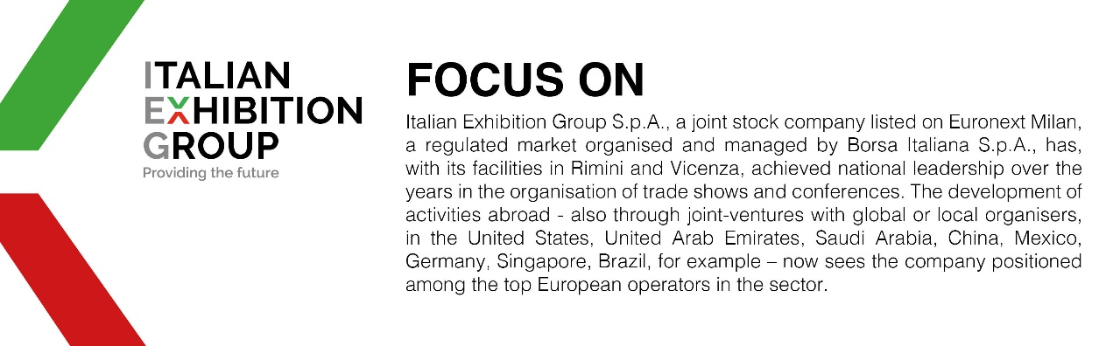

This press release contains forecast elements and estimates that reflect the management’s current opinions (“forward-looking statements”), particularly regarding future management performance, realization of investments, cash flow trends and the evolution of the financial structure. For their very nature, forward-looking statements have a component of risk and uncertainty, as they depend on the occurrence of future events. The effective results may differ (even significantly) from those announced, due to numerous factors, including, only by way of example: food service market and tourist flow trends in Italy, gold and jewellery market trends, green economy market trends; the evolution of raw material prices; general macroeconomic conditions; geopolitical factors and evolutions in the legislative framework. Moreover, the information contained in this release does not claim to be complete, and has not been verified by independent third parties. Forecasts, estimates and objectives contained herein are based on the information available to the Company as at the date of this release.

