
press release
THE 28TH EDITION OF ECOMONDO, THE INTERNATIONAL
ECOLOGICAL TRANSITION HUB, KICKS OFF TOMORROW

- At Rimini Expo Centre until 7th November, more than 1,700 exhibiting brands, 380 hosted buyers, over 30 official foreign delegations and 90 international associations for an increasingly global edition
- On 4th and 5th November, the 14th edition of the States General of the Green Economy
Rimini, 3rd November 2025 – The next chapter on global ecological transition will be written at Rimini Expo Centre.
The 28th edition of Ecomondo begins tomorrow, Tuesday 4th November, and will continue until Friday 7th November. A reference point in Europe and the Mediterranean area for the green, blue and circular economies, the event, organized by Italian Exhibition Group (IEG), confirms its role as an international hub for research and innovation, bringing together institutions, businesses and the scientific world to discuss challenges and opportunities related to environmental policy and the transition to a circular economy.
Ecomondo 2025 will be inaugurated at an Opening Ceremony scheduled for Tuesday, 4th November at 10.30 am in the Innovation Arena – South Hall, attended by Maurizio Ermeti, President of Italian Exhibition Group, Michele De Pascale, President of the Emilia-Romagna Region, Jamil Sadegholvaad, Mayor of Rimini, Fabio Fava, Coordinator of Ecomondo’s Technical Scientific Committee, and the Honourable Jacopo Morrone, President of the Bicameral Ecomafia Commission.
Gilberto Pichetto Fratin, Minister for the Environment and Energy Security, will not be attending tomorrow due to institutional commitments, but he will be at Ecomondo on Thursday, 6th November.
Ecomondo’s opening day will also coincide with the first session of the 14th edition of the States General of the Green Economy, organized by the Sustainable Development Foundation in collaboration with the Ministry of the Environment and Energy Security (MASE) and promoted by the National Council of the Green Economy, which will examine the state of the European green economy in the new global context.
This will be followed on Wednesday 5th November by an international plenary session, held entirely in English for the first time in order to further expand the scope of the event.

The numbers confirm the high profile of the event: over 1,700 exhibiting brands, 18% of which from abroad, and 380 hosted buyers from 66 countries. The picture is completed by official delegations arriving from 30 countries and around 90 international trade associations, thanks to synergy with the Italian Trade Agency (ICE) and the Ministry of Foreign Affairs and International Cooperation.
The four-day conference programme foresees over 200 events, 70 of which organized by the Technical Scientific Committee, with in-depth discussions on crucial topics such as WEEE and critical raw materials, textiles, sustainable finance, water resource management and the blue economy, AI, digital twins, bioenergy, the circular economy and predictive resource management. Particular attention will be paid to the African continent with the fifth edition of the Africa Green Growth Forum.
Not-to-be-missed events on the opening day include:
- ESG CEO SUMMIT – Sustainable future between compliance and competitiveness”, organized by Ecomondo’s Technical Scientific Committee, now at its second edition. The meeting will bring together CEOs and representatives from large companies to explore the conditions for a fair ecological transition in which European companies play a leading role in the global context.
- “Managing climate risk: insurance products and obligations for companies”, organized by Ecomondo’s Technical and Scientific Committee & Forum for Sustainable Finance.
- “Circular economy best practice for WEEE, waste batteries and packaging waste: from policy development to industrial case studies”, organized by Ecomondo’s Technical Scientific Committee and Erion.
- “European and Mediterranean nature-based, digital and cyber-physical initiatives projects to innovate water management”, organized by Ecomondo’s Technical Scientific Committee, Utilitalia, IRSA-CNR (Water Research Institute), the University Polytechnic of the Marche, ISPRA, WATER4ALL and Water Europe.
- “Coastal regeneration as key driver for climate change adaption”, organized by Ecomondo’s Technical Scientific Committee, the Ministry of the Environment and Energy Security, ISPRA, GNRAC, CPMR.
The full programme of Ecomondo 2025 events is available on the following link:
https://www.ecomondo.com/it/eventi/palinsesto-convegnistico/programma
Ecomondo 2025 will occupy 166,000 square metres of exhibition space with a total of 30 halls divided into seven macro-areas: Waste as Resource, Water Cycle & Blue Economy, Sites & Soil Restoration, Bioenergy & Agriculture, Earth Observation & Environmental Monitoring, Circular and Regenerative Bio-Economy, with the return of SAL.VE, the biennial Exhibition of Ecological Vehicles for Ecology, in partnership with ANFIA.
There will also be six vertical districts dedicated to the Blue Economy, Circular Healthy City, Paper District, Textile District, Trenchless District and the Innovation District, which will host 40 innovative Italian and international start-ups and SMEs, as well as the Green Jobs & Skills initiative that aims to match labour supply and demand in the sustainability and ecological transition sector.
New at Ecomondo 2025: a series of themed tours on plastic, water, soil and innovation, available in Italian and English, with over 500 free places per day.

INSTITUTIONAL PARTNERS
Ecomondo 2025 is organized by Italian Exhibition Group with the collaboration of: the European Commission; Ministry of the Environment and Energy Security; Ministry of Enterprise and Made in Italy; Agenzia ICE - Italian Trade & Investment Agency; Emilia-Romagna Region; Rimini Municipal Council; ANCI (National Association of Italian Municipalities); ANFIA (National Automotive Industry Association); ART-ER; CIB (Italian Biogas Consortium); CIC (Italian Composter Consortium); CONAI (National Packaging Consortium); ENEA; Assoambiente; Sustainable Development Foundation; ISPRA (Environmental Protection and Research Institute); Legambiente; UNICIRCULAR (Assoambiente section); UNACEA (National Union of Construction Equipment & Attachments Companies); UTILITALIA; CIHEAM (International Centre For Advanced Mediterranean Agronomic Studies); CBE JU (Circular Bio-based Europe Joint Undertaking); EBA (European Biogas Association); European Environment Agency; ISWA (International Solid Waste Association); WBA (World Biogas Association); Water Europe.

ABOUT ECOMONDO 2025
Event: International trade show; Organization: Italian Exhibition Group S.p.A.; Frequency: annual; Edition: 28th; Dates: 4-7 November 2025; mail: ecomondo@iegexpo.it; Website: www.ecomondo.com; Facebook: www.facebook.com/EcomondoRimini; LinkedIn: https://www.linkedin.com/company/ecomondo-the-green-technologies-expo/

PRESS CONTACT IEG/ECOMONDO 2025
head of media relation & corporate communication: Elisabetta Vitali; press office manager: Pierfrancesco Bellini; international press office coordinator: Silvia Giorgi; media@iegexpo.it

MEDIA AGENCY IEG/ECOMONDO: Smartitaly Communications
Edoardo Chiesa, +39 333 8744340 - e.chiesa@smartitaly.it; Paola Gervasio, +39 346 6064272 - p.gervasio@smartitaly.it; Francesca Pericolo, +39 327 9861860 - f.pericolo@smartitaly.it; Stampa estera - Andrea Indiano, +39 349 3232557 – a.indiano@smartitaly.it

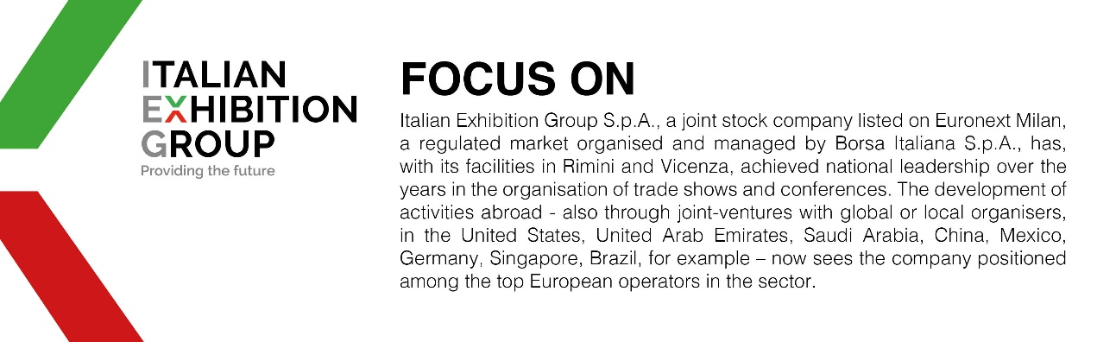

This press release contains forecast elements and estimates that reflect the management’s current opinions (“forward-looking statements”), particularly regarding future management performance, realization of investments, cash flow trends and the evolution of the financial structure. For their very nature, forward-looking statements have a component of risk and uncertainty, as they depend on the occurrence of future events. The effective results may differ (even significantly) from those announced, due to numerous factors, including, only by way of example: food service market and tourist flow trends in Italy, gold and jewellery market trends, green economy market trends; the evolution of raw material prices; general macroeconomic conditions; geopolitical factors and evolutions in the legislative framework. Moreover, the information contained in this release does not claim to be complete, and has not been verified by independent third parties. Forecasts, estimates and objectives contained herein are based on the information available to the Company as at the date of this release.

