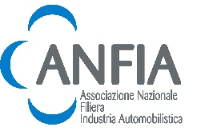

press release

ECOMONDO AND ANFIA: SAL.VE,
THE BIENNIAL EXHIBITION OF ECOLOGICAL VEHICLES, IS BACK

- On display at IEG’s Rimini Expo Centre from 4th to 7th November, the entire range of industrial vehicles and special equipment for waste collection and street sweeping.

- Marco Orecchia, President of ANFIA's Ecological Services Vehicles Section: “Participation in SAL.VE is strategic for our Section in order to achieve the goal of increasing the export share of our highly specialized companies.”

Rimini, 3rd November 2025 – SAL.VE, the biennial Exhibition of Ecological Vehicles, is back at Ecomondo 2025, in partnership with ANFIA, the National Automotive Industry Association.

From 4th to 7th November, the Exhibition will join the other six macro-areas represented at Ecomondo, the green, blue and circular economy event organized by Italian Exhibition Group at Rimini Expo Centre.

SAL.VE will be staged in halls A7 and C7 (West entrance) in a special exhibition area of the expo centre: an opportunity to display, within the international showcase offered by Ecomondo, the urban hygiene supply chain at the service of territorial enhancement with the entire range of equipment for industrial and special vehicles for collecting solid and liquid waste, street sweeping and sewage disposal.

THE SECTOR’S NUMBERS
ANFIA's Ecological Services Vehicles Section represents Italian manufacturing excellence in the field of equipment for the collection and transport of solid, liquid and hazardous waste, sewage disposal and street cleaning. Technological innovation and product sustainability characterize the 19 member companies, which, with a turnover of approximately 630 million euros and more than 1,650 direct employees, represent over 70% of the sector in Italy.
Highly committed to ecological transition, the associates have been working for some time to make vehicles and equipment increasingly eco-sustainable to ensure their fundamental contribution to reducing noise pollution and cutting emissions from urban waste collection and street cleaning. These activities are increasingly important in order to comply with plans to improve air quality in urban areas.
As regards the vehicle fleet, in 2024, 61,021 vehicles with closed, top or rear opening, tipping containers for transporting solid waste, 6,287 cesspool emptying tanks, 3,549 vehicles equipped with sweepers, 923 vehicles for washing waste containers, 76 road sweepers and 62 municipal solid waste compactors were on the Italian roads (ANFIA analysis of ACI data).

WEAK ITALIAN MARKET, EXPORTS TO OVERCOME FRAGMENTATION ARE INCREASING
“After 2024, when the Italian market for ecological service vehicles closed with a decline of more than 10% compared to the previous year due to double-digit decreases in both the solid urban waste transport vehicle sector and the special waste tanker sector,” says Marco Orecchia, President of ANFIA's Ecological Services Vehicles Section, “the market is still weak for all sectors in 2025, with a particularly sharp decline in road cleaning vehicle sales, while only bilateral loading equipment is going against the trend.
In terms of power sources, despite an expansion in the range of models available on the market, the market share of electric vehicles is still very limited, almost non-existent in the medium-heavy vehicle segment (12 tonnes and above).
In our country, there is also a high degree of fragmentation in the supply chain (the highest in Europe), which, on the one hand, puts strong pressure on product prices and therefore on manufacturers' margins, and on the other, pushes even the smallest companies to look to new markets. It is precisely in this context that participation in SAL.VE – an important international showcase among the major sustainability and green technology trade shows – is strategic for our Section in order to achieve the objective of increasing the export share of our highly specialised companies.”

SAL.VE is therefore the ideal event for discovering technologies and solutions applied to ecological service vehicles for the transition towards cleaner and more resilient cities.

INSTITUTIONAL PARTNERS
Ecomondo 2025 is organized by Italian Exhibition Group with the collaboration of: the European Commission; Ministry of the Environment and Energy Security; Ministry of Enterprise and Made in Italy; Agenzia ICE - Italian Trade & Investment Agency; Emilia-Romagna Region; Rimini Municipal Council; ANCI (National Association of Italian Municipalities); ANFIA (National Automotive Industry Association); ART-ER; CIB (Italian Biogas Consortium); CIC (Italian Composter Consortium); CONAI (National Packaging Consortium); ENEA; Assoambiente; Sustainable Development Foundation; ISPRA (Environmental Protection and Research Institute); Legambiente; UNICIRCULAR (Assoambiente section); UNACEA (National Union of Construction Equipment & Attachments Companies); UTILITALIA; CIHEAM (International Centre For Advanced Mediterranean Agronomic Studies); CBE JU (Circular Bio-based Europe Joint Undertaking); EBA (European Biogas Association); European Environment Agency; ISWA (International Solid Waste Association); WBA (World Biogas Association); Water Europe.

ABOUT ECOMONDO 2025
Event: International trade show; Organization: Italian Exhibition Group S.p.A.; Frequency: annual; Edition: 28th; Dates: 4-7 November 2025; mail: ecomondo@iegexpo.it; Website: www.ecomondo.com; Facebook: www.facebook.com/EcomondoRimini; LinkedIn: https://www.linkedin.com/company/ecomondo-the-green-technologies-expo/

PRESS CONTACT IEG/ECOMONDO 2025
head of media relation & corporate communication: Elisabetta Vitali; press office manager: Pierfrancesco Bellini; international press office coordinator: Silvia Giorgi; media@iegexpo.it

MEDIA AGENCY IEG/ECOMONDO: Smartitaly Communications
Edoardo Chiesa, +39 333 8744340 - e.chiesa@smartitaly.it; Paola Gervasio, +39 346 6064272 - p.gervasio@smartitaly.it; Francesca Pericolo, +39 327 9861860 - f.pericolo@smartitaly.it; Stampa estera - Andrea Indiano, +39 349 3232557 – a.indiano@smartitaly.it

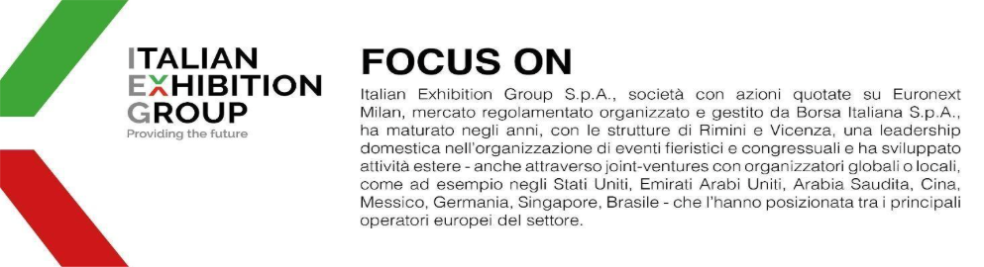
ANFIA PRESS OFFICE
Manager: Miriam Gangi – m.gangi@anfia.it Tel. 011 5546502, mob. 338 7303167
Mariangela Sciorati – m.sciorati@anfia.it Tel. 011 5546521, mob. 342 8633604

ANFIA – National Automotive Industry Association
Founded in 1912, for over 100 years, the Association’s aim has been to represent the interests of its members in dealings with national and international public and private institutions and to study and resolve technical, economic, fiscal, legislative, statistical and quality issues in the automotive sector.
The Association is divided into 3 product groups, each coordinated by a President. Components: includes manufacturers of motor vehicle parts and components; Car Design & Engineering: includes companies operating in the field of design, engineering, styling and design of motor vehicles and/or parts and components for the automotive sector; Manufacturers: includes motor vehicle producers in general – including trucks, trailers, motorhomes, special vehicles and/or vehicles for specific uses – in other words, specific fittings and equipment mounted on motor vehicles.
The automotive production chain in Italy includes 5,451 companies and 273,000 employees (direct and indirect), representing 7.1% of employment in the Italian manufacturing sector, with a turnover of €113.3 billion, equal to 9% of manufacturing turnover in Italy and 5.8% of Italian GDP, and €71 billion in tax revenue from motor vehicles.
Website: www.anfia.it: X: x.com/ANFIA_it; LinkedIn: www.linkedin.com/company/anfia-it

